***The Golden Fleece (Zolotoe runo,* 1906-1909*)***

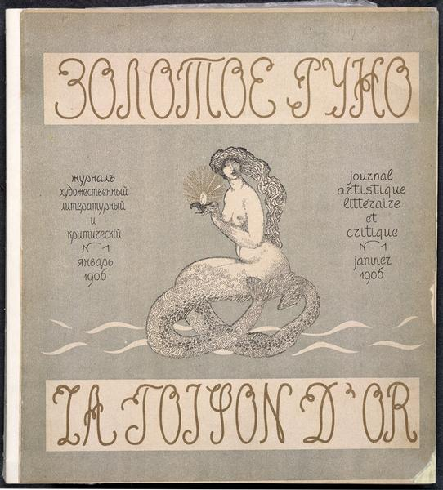The successor to the *World of Art*, the Symbolist art-literary journal *The Golden Fleece (Zolotoe runo*, 1906-1909), was published in Moscow by the offspring of the wealthy merchant family, Nikolai Riabushinsky (1877-1951), and ran for 48 issues. It became a rival to the literary periodical *The Scales* (*Vesy,* 1904-1909), edited by Symbolist poet Valery Briusov (1873-1924). The quest implied in the title and expressed in the editorial manifesto was an articulation of the Symbolist notion of the search for beauty and the value of art. Contemporaries, however, criticized the journal and believed that it did not express anything new or fresh. For the first six months it was published in Russian and French articulating the cosmopolitan desire to promote Russian art and literature in Europe. The Symbolist artists of the future art group Blue Rose (*Golubaia roza*, organized in 1907) created the look of *The Golden Fleece*. The periodical printed the highest quality reproductions and used expensive imported enameled and silk paper. By 1909, the journal gradually lost its luxurious look and ceased publication after Riabushinskii’s bankruptcy.

Title page of first issue of *The Golden Fleece*

*(Zolotoe runo),* 1906, no. 1. Attributed to

Nikolai Feofilaktov.

**References and Suggested Further Reading**

Bogomolov, Nikolai (2004), “K istorii ‘Zolotogo runa’,” *Ot Pushkina do Kibirova. Stat’i o russkoi literature, preimushchestvenno o poezii*, Moskva: Novoe literaturnoe obozrenie: 41-83.

This article contains a re-publication of correspondence between The Golden Fleece’s participants. It is a valuable source for graduate students.

Dumova, N. (1992), “Nikolai Riabushinskii: ‘Zolotoe runo’ i ‘Golubaia roza’,” *Kentavr* January: 83-95.

This article contains important information regarding the history of the journal and provides information about its editor-in-chief Nikolai Riabushinsky.

Gofman, Ida (2007), *Zolotoe runo. Zhurnal, vystavki: 1906-1909,* Moskva: Russkii raritet.

This richly printed edition is a survey of art and graphic design in the journal. Contains excellent facsimile reproductions from The Golden Fleece. A good start for undergraduates who are interested in the journal’s visual appearance.

Kennedy, Janet (1999), “*The World of Art* and Other Turn-of-the-Century Russian Art Journals, 1898-1910,” *Defining Russian Graphic Arts,* ed. Alla Rosenfeld, New Brunswick, NJ & London: Rutgers UP: 63-78.

A good survey article devoted to the major Russian Modernist periodicals and their look. A good start for undergraduates.

Lavrov, A.V. (1984), “Zolotoe runo,” *Russkaia literatura i zhurnalistika nachala XX veka. 1905-1917. Burzhuazno-liberal’nye i modernistskie izdaniia*, ed. B.A. Bialik, Moskva: Nauka: 137-173.

A historical overview of *The Golden Fleece* with an emphasis on its department of literature. A good start for undergraduate students.

Richardson, William (1986), *Zolotoe Runo and Russian Modernism: 1905-1910,* Ann Arbor: Ardis Publishers.

The most comprehensive study of The Golden Fleece. A well-written work that focuses on the journal’s organization, its literary content and exhibits. An excellent source for both undergraduates and graduate students.

**Hanna Chuchvaha, University of Alberta**

URL source:

<http://www.vads.ac.uk/large.php?uid=50874>

Collection: Russian Visual Arts Project

Contributor: British Library, on behalf of Russian Visual Arts Project